EC4307: WEB APPLICATION DEVELOPMENT

WEB-PROJECT ERD AND MOCK UI

NAME : TENNEKOON T.M.T.A.B.

REG. NO : EG/2022/5364

SEMESTER : 04

DATE : 27/06/2025

PROJECT: EVENTS MANAGEMENT AND RSVP SYSTEM AS A WEBSITE

# Project Overview

The RSVP Event Management System is a web-based platform designed to streamline the process of organizing and managing events, sending invitations, collecting RSVPs, and gathering post-event feedback. It empowers users to create events, select recipients, and automate reminders, while attendees can easily respond and share feedback. The system addresses a common day-to-day challenge: the inefficiency and confusion involved in manually tracking event responses and follow-ups, especially for personal gatherings, meetings, or community events. By digitizing this workflow, it ensures clear communication, improved planning, and a smoother event experience for both organizers and participants.

# Data Requirement and Database Structure Analysis

The RSVP Event Management System requires a structured relational database to efficiently manage user accounts, events, invitations, reminders, and feedback. The core data entities include users, who register with a unique email and can create events. Each event stores information such as title, date, location, and is linked to its creator. Invitations are tracked per event and recipient, along with their RSVP status. Organizers can set multiple reminder intervals for events through the event_reminders table. Additionally, attendees can provide post-event feedback, which is associated with both the user and the event. This schema ensures data integrity through foreign key relationships and supports all functional aspects of the system.

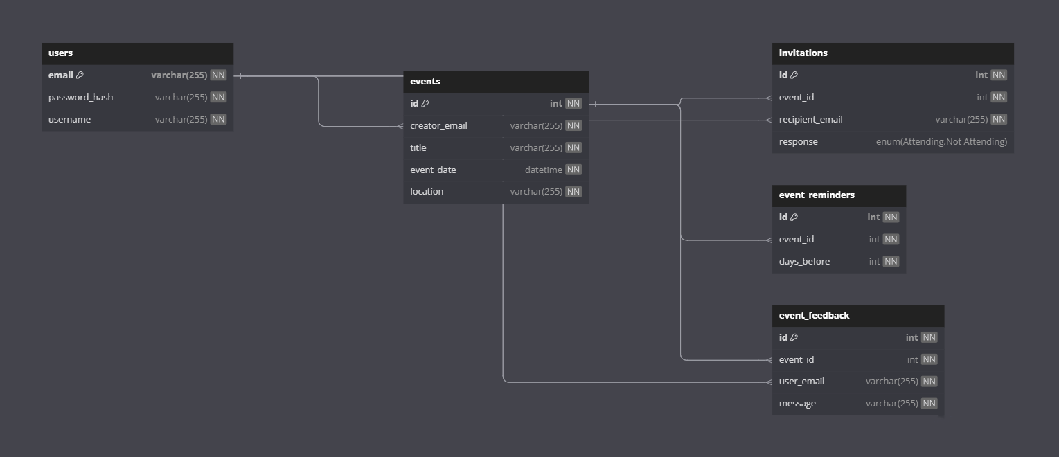

Figure : Relational Schema Diagram of Proposed Database